|  |  |  |
| --- | --- | --- |
| **C:\Users\hi\AppData\Local\Temp\ksohtml4304\wps1.jpg** | **ಕೆ. ವಿ. ಜಿ. ತಾಂತ್ರಿಕ ಮಹಾವಿದ್ಯಾಲಯ, ಸುಳ್ಯ, ,ದ.ಕ -574 327**  **k.v.g college of engineering, sullia, d.k. – 574 327**  **(affiliated to visvesvaraya technological university, belagavi)** | **C:\Users\hi\AppData\Local\Temp\ksohtml4304\wps2.png** |

**DEPARTMENT COMPUTER SCIENCE AND ENG(AI & ML)**



**MANUAL FOR**

**Technical Writing using LaTeX**

**(skill enhancement course)**

**COURSE CODE:- BCS456D**

**4TH SEMESTER**

**ACADEMIC YEAR:- 2023-24**

**STUDENT NAME -- USN**

**PAVAN M 4KV22CI036**

|  |  |  |
| --- | --- | --- |
| **C:\Users\hi\AppData\Local\Temp\ksohtml4304\wps1.jpg** | **ಕೆ. ವಿ. ಜಿ. ತಾಂತ್ರಿಕ ಮಹಾವಿದ್ಯಾಲಯ, ಸುಳ್ಯ, ,ದ.ಕ -574 327**  **k.v.g college of engineering, sullia, d.k. – 574 327**  **(affiliated to visvesvaraya technological university, belagavi)** | **C:\Users\hi\AppData\Local\Temp\ksohtml4304\wps2.png** |

**DEPARTMENT COMPUTER SCIENCE AND ENG (AL & ML)**



**CERTIFICATE**

This is to certify that Mrs./Mr. **Pavan M**, USN-**4KV22CI036** has satisfactorily completed the practical component of skill enhancement course-BCS456D,Computer Science & Eng(AI & ML) for the 4th semester B.E Program during the academic year 2023-24.

|  |  |
| --- | --- |
| **Sessional Marks** | |
| **Max. Marks:** | **Marks Awarded:** |

Signature of Staff Signature of HOD

List of experiments

|  |  |  |  |  |
| --- | --- | --- | --- | --- |
| **SI.No** | **Experiments** | **Page.No** | **Marks Awarded** | **Staff signature** |
| 1. | Develop a LaTeX script to create a simple document that consists of 2 sections [Section1, Section2], and a  paragraph with dummy text in each section. And also include header [title of document] and footer [institute  name, page number] in the document. |  |  |  |
| 2. | Develop a LaTeX script to create a document that displays the sample Abstract/Summary. |  |  |  |
| 3. | Develop a LaTeX script to create a simple title page of the VTU project Report .[Use suitable Logos and text  formatting] |  |  |  |
| 4. | Develop a LaTeX script to create the Certificate Page of the Report. [Use suitable commands to leave the  blank spaces for user entry] |  |  |  |
| 5. | Develop a LaTeX script to create a document that contains the following table with proper labels.   |  |  |  |  |  |  | | --- | --- | --- | --- | --- | --- | | **SI.NO** | **USN** | **Student Name** | **Marks** | | | | **Sub 1** | **Sub 2** | **Sub 3** | | 1. | 4KV22CI001 | Name 1 | 89 | 60 | 90 | | 2. | 4KV22CI002 | Name 2 | 78 | 45 | 98 | | 3. | 4KV22CI003 | Name 3 | 67 | 55 | 59 | |  |  |  |
| 6. | Develop a LaTeX script to include the side-by-side graphics/pictures/figures in the document by using the  sub graph concept. |  |  |  |
| 7. | Develop a LaTeX script to create a document that consists of the following two mathematical equations. |  |  |  |
| 8. | Develop a LaTeX script to demonstrate the presentation of Numbered theorems, definitions, corollaries,  and lemmas in the document . |  |  |  |
| 9. | Develop a LaTeX script to create a document that consists of two paragraphs with a minimum of 10 citations  in it and display the reference in the section . |  |  |  |
| 10. | Develop a LaTeX script to design a simple tree diagram or hierarchical structure in the document with  appropriate labels using the Tikz library . |  |  |  |
| 11. | Develop a LaTeX script to present an algorithm in the document using algorithm/algorithmic/algorithm2e  Library . |  |  |  |
| 12. | Develop a LaTeX script to create a simple report and article by using suitable commands and formats of  user choice. |  |  |  |

|  |  |  |
| --- | --- | --- |
| **Marks Distribution** | **Max.Mark** | **Marks awarded** |
| Average Marks Scaled Up |  |  |

|  |  |  |
| --- | --- | --- |
| Lab Test Marks |  |  |
| Total Marks in the Practical Component of the Course |  |  |
| Signature of the Staff with date |  | |

**1. Develop a LaTeX script to create a simple document that consists of 2 sections [Section1, Section2], and a paragraph with dummy text in each section. And also include header [title of document] and footer [institute name, page number] in the document.**

\documentclass[12pt,a4paper]{article}

\usepackage[left=2cm,right=2cm,top=2cm,bottom=2cm]{geometry}

\usepackage{fancyhdr}

\begin{document}

\pagestyle{fancy}

\title{LaTeX Project}

\fancyhf{} % clear existing header/footer entries

% We don't need to specify the O coordinate

\fancyhead{} % clear all header fields

\fancyhead[R]{LaTeX Project}

\fancyfoot{} % clear all footer fields

\fancyfoot[LO,CE]{KVG College of Enginnering}

\fancyfoot[R]{\thepage}

\maketitle

\section{About KVGCE}

KVG College of Engineering (KVGCE) is one of many engineering colleges in Karnataka, India. It was established in 1986 based on one of the government aided initiatives in technical education in Southern Karnataka State. It is located in Kurunjibhag, Sullia, Dakshina Kannada and is affiliated to Visvesvaraya Technological University (VTU), Belgaum.

KVGCE has an Academy of Liberal Education led by Founder and Chairman Kurunji Venkatramana Gowda and Active General Secretary K.V.Renuka Prasad.

\section{About dep computer science and Eng(AI and ML)}

Al and ML course is dedicated to research, development and application of that shape the future of technology and society. This course plays a crucial role in advancing the field of AL and ML, contributing to various domain such as healthcare, finance, robotics, natural language processing, computer vision and more.

\subsection{Program Education Objectives}

\begin{itemize}

\item PEO1: Apply Engineering Basics Analyze Engineering Challenges through application of mathematical and Algorithmic principles for real life technology projects.

\item PEO2: Engineering Skills and techniques Apply skills like Analyzing, Designing, Implementing and Testing of Major and Minor Projects

\item PEO3: Individual and Team Work Exhibit collaborative abilities in the engineering projects like Communication Skill, work as individual or in a team with a sense of Social Responsibility

\item PE04: Life Long Learning Initiate technological and skills required for comprehensive contribution as experts in the Chosen Profession.

\end {itemize}

\subsection{Program Specific Outcomes}

\begin{itemize}

\item PSO1: PROBLEM SOLVING SKILLS Specify, design, build and test analog, digital and embedded systems for signal processing.

\item PSO2: PROFESSIONAL SKILLSUnderstand and architect wired and wireless analog and digital communication systems as per specifications, and determine their performance

\item PS03: ETHICS AND CAREER DEVELOPMENTExhibit skills required for a successful career in the industry based on principles of software project management, teamwork, ethical practices, develop the spirit of free enterprise and provide innovative ideas towards analysis.

\end {itemize}

\end{document}

**OUTPUT:-**

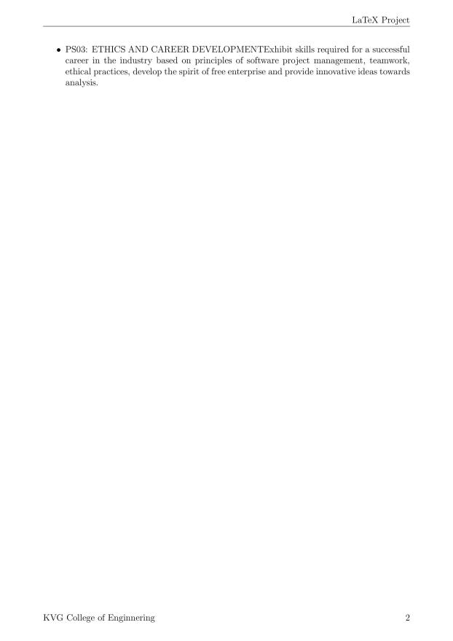

**2.Develop a LaTeX script to create a document that displays the sample Abstract/Summary .**

\documentclass[10pt,a4paper]{article}

\usepackage[utf8]{inputenc}

\usepackage{amsmath}

\usepackage{amsfonts}

\usepackage{amssymb}

\usepackage[left=3cm,right=3cm,top=2cm,bottom=2cm]{geometry}

\begin{document}

\thispagestyle{plain}

\begin{center}

\Large

\textbf{COVID-19 and Comorbid}

\vspace{0.4cm}

\large

AI in Medical Field

\vspace{0.9cm}

\textbf{Abstract}

\end{center}

The advent of COVID-19 marks a significant turning point in medical history, leading to

increased reliance on advanced technologies such as deep learning models. These models have

become indispensable for promptly identifying COVID-19 in medical images obtained through

Computerized Tomography (CT), Ultrasound, and X-ray scans. This study aims to equip

healthcare professionals with an additional tool to improve the formulation of effective

treatment plans and containment strategies for the disease. A new hybrid architecture called

MobNetCov19 has been introduced for diagnosing COVID-19 in patients with comorbidities,

utilizing a Convolutional Neural Network (CNN) model. The research investigates optimized

versions of VGG19, ResNetRS152, and MobNetCov19 (VRM) models, facilitating a

comparative assessment of different imaging modalities. Despite the limited availability of

COVID-19 datasets, sophisticated detection models have been carefully developed.

\\

Keywords: Convolutional Neural Network, Computerized Tomography, Coronavirus-19,

MobNetCov19, VRM.

\\

\textbf{Summary}

The study reveals that CT scans excel in disease detection compared to X-ray and Ultrasound

scans. Researchers tested three models—VGG19, ResNetRS152, and MobNetCov19—

carefully adjusting parameters for accuracy. Augmentation techniques significantly improved

the models' precision, particularly in early disease detection. Limited data availability posed a

challenge for training more complex models. Results indicate that CT and Ultrasound datasets

outperform X-ray data in disease detection. The MobNetCov19 model, fine-tuned rigorously,

achieved impressive accuracy rates of 98\% for CT, 98\% for Ultrasound, and 96\% for X-Ray

data.

\end{document}

**OUTPUT:-**

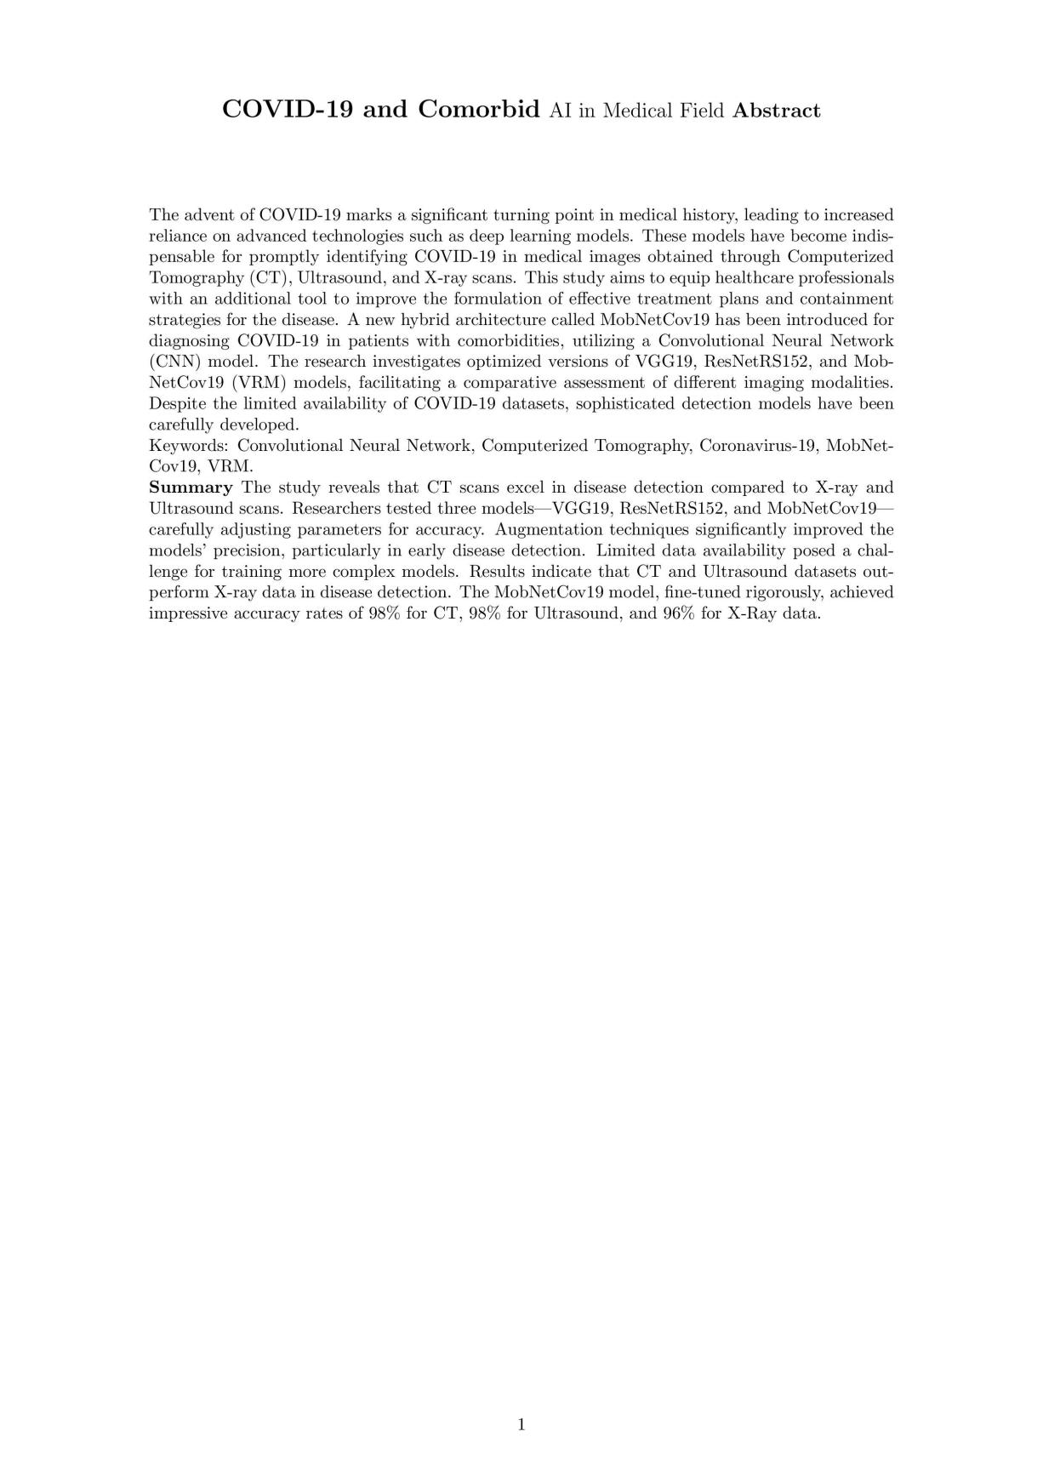

**3. Develop a LaTeX script to create a simple title page of the VTU project Report. [Use suitable Logos and text formatting]**

\documentclass{report}

\usepackage{graphicx}

\usepackage{setspace}

\usepackage{geometry}

\newcommand{\titlepageVTU}{

\begin{titlepage}

\begin{center}

\textbf{\LARGE KVG College of Engineering,Sullia} \\

\begin{figure}

\centering

\includegraphics[width=0.3\linewidth]{vtu logo.png}

\end{figure}

\vspace*{1cm}

\textbf{\LARGE Visvesvaraya Technological University}\\

\vspace{0.5cm}

{\Large Department of Computer Science and Eng(AI & ML)} \\% Replace with your department name

\vspace{2cm}

{\huge\textbf{COVID-19}}\\ % Replace with your project title

\vspace{2cm}

\textbf{\Large by}

\vspace{0.5cm}

{\Large Pavan} % Replace with your name

\vfill

\textbf{\Large Prof. Suresh} % Replace with your guide's name

\vspace{0.5cm}

{\Large Your Co-guide's Name (if any)} % Replace with your co-guide's name, if any

\vfill

{\large 4th Semester, 2024} % Replace with semester and year

\end{center}

\end{titlepage}

}

\begin{document}

\titlepageVTU % Insert custom title page

\end{document}

**OUTPUT:-**



1. **Develop a LaTeX script to create the Certificate Page of the Report [Use suitable commands to leave the blank spaces for user entry] .**

\documentclass[a4paper]{article}

\usepackage{tcolorbox}

\usepackage[dvisvgm, usenames, dvipsnames]{color}

\begin{document}

\begin{titlepage}

\begin{tcolorbox}[colframe=black, colback=white, boxrule=2pt, arc=0pt, outer arc=0pt]

\begin{center}

\vspace{1cm}

\textbf\Large{K V G COLLEGE OF ENGINEERING \\[7pt]

SULLIA,57423 \\ [7pt]

DEPARTMENT OF COMPUTER SCIENCE AND ENG(AI & ML)\\

}

\vspace{1cm}

\includegraphics[width=0.3\textwidth]{vtu logo.png}\\

\vspace{1cm}

\textbf{\underline{CERTIFICATE}}

\end{center}

\doublespacing

This is to certify that \textbf{\color{darkblue}PAVAN M} has submitted the Report on \textbf{\color{darkblue}"OntoCopy: COVID-19”} for the fulfillment of \textbf{IV semester Computer Science and Engineering},

by the \textbf{VTU ENGINEERING COLLLEGE} for the academic year 2023-2024. The report has been approved as it satisfies the academic requirements in respect of work guidelines prescribed for the said degree.

\vspace{2cm}

\noindent \\ % Prevent indentation

\begin{minipage}[t]{0.5\textwidth}

\begin{tabular}[t]{@{}c}

\rule{10em}{0.4pt}\\

\textbf{Examiner 1} \\

\end{tabular}

\end{minipage}%

\begin{minipage}[t]{0.5\textwidth}

\begin{flushright}

\begin{tabular}[t]{@{}c}

\rule{10em}{0.4pt}\\

\textbf{Examiner 2} \\

\end{tabular}

\end{flushright}

\end{minipage}

\vspace{1.5cm}

\noindent % Prevent indentation

\end{tcolorbox}

\end{titlepage}

\end{document}

**OUTPUT:-**



**5. Develop a LaTeX script to create a document that contains the following table with proper labels.**

|  |  |  |  |  |  |
| --- | --- | --- | --- | --- | --- |
| **SI.NO** | **USN** | **Student Name** | **Marks** | | |
| **Sub 1** | **Sub 2** | **Sub 3** |
| 1. | 4KV22CI001 | Name 1 | 89 | 60 | 90 |
| 2. | 4KV22CI002 | Name 2 | 78 | 45 | 98 |
| 3. | 4KV22CI003 | Name 3 | 67 | 55 | 59 |

\documentclass[10pt,a4paper]{article}

\usepackage[utf8]{inputenc}

\usepackage{amsmath}

\usepackage{amsfonts}

\usepackage{amssymb}

\usepackage[left=2cm,right=2cm,top=2cm,bottom=2cm]{geometry}

\usepackage{multirow}

\begin{document}

\begin{center}

\begin{Large}

\textbf{Table : Students Details of 4th semester CSE}

\end{Large}

\end{center}

\section*{Marks Details:-}

\begin{tabular}{|c|c|c|c|c|c|}

\hline

\multirow{2}{*}{S.No} & \multirow{2}{*}{USN} & \multirow{2}{*}{Student Name} &

\multicolumn{3}{c|}{Marks} \\

\cline{4-6}

& & & sub 1 & sub 2 & sub 3\\

\hline

1 & 4KV22CI001 & Name 1 1 & 45 & 77 & 97 \\

\hline

2 & 4KV22CI002 & Name 2 & 74 & 78 & 66 \\

\hline

3 & 4KV22CI003 & Name 3 & 88 & 82 & 79 \\

\hline

\end{tabular}

\end{document}

**OUTPUT:-**

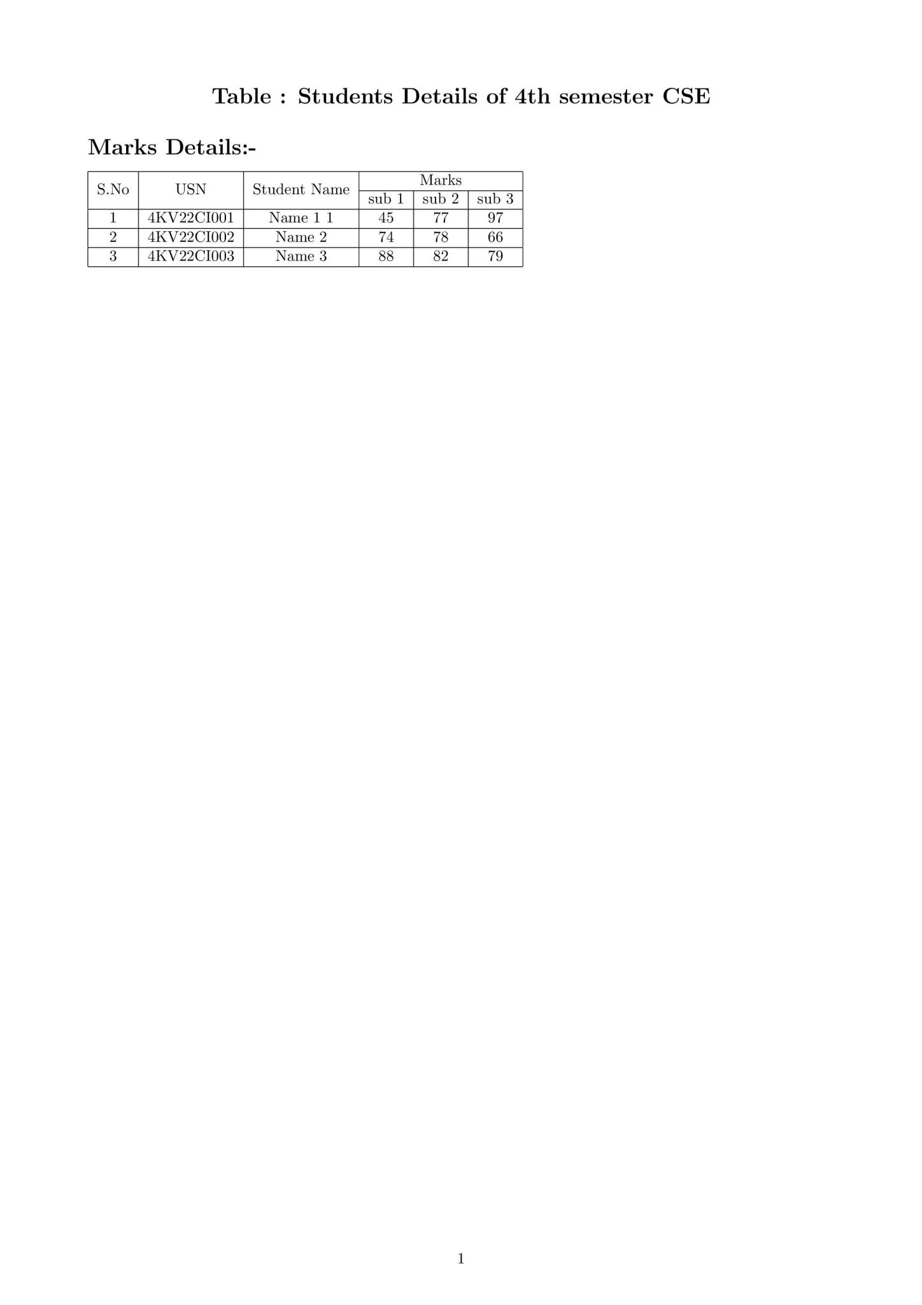

**6.Develop a LaTeX script to include the side-by-side graphics/pictures/figures in the document by using the sub-graph concept.**

\documentclass{article}

\usepackage{graphicx}

\usepackage{subcaption}% For side-by-side

\begin{document}

\textbf{\huge Side-by-Side Subgraph}

\begin{figure}[ht]

\subfloat[First Dataset Accuracy]{

\begin{minipage}[c][1\width]{

0.3\textwidth}

\centering

\includegraphics[width=1\textwidth]{Fig3.jpeg}

\end{minipage}}

\hfill

\subfloat[Second Dataset Accuracy]{

\begin{minipage}[c][1\width]{

0.3\textwidth}

\centering

\includegraphics[width=1.1\textwidth]{Fig11.jpeg}

\end{minipage}}

\hfill

\subfloat[Comparison]{

\begin{minipage}[c][1\width]{

0.3\textwidth}

\centering

\includegraphics[width=1.2\textwidth]{Fig15.jpeg}

\end{minipage}}

\caption{Performance Analysis}

\end{figure}

\end{document}

**OUTPUT:-**

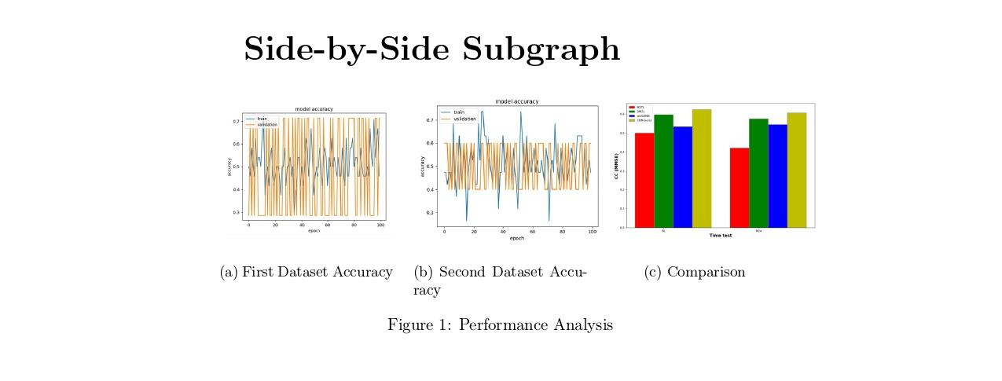

**7. Develop a LaTeX script to create a document that consists of the following two mathematical equations.**

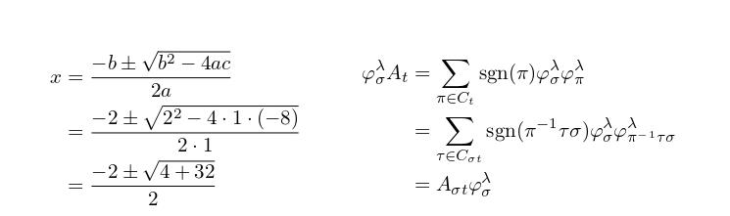

\documentclass{article}

\usepackage{amsmath} % This package is required for the 'aligned' environment

\begin{document}

\title{Following Two Mathematical Equations}

\date{}

\maketitle

% Use the 'align' environment to align equations properly

\[

\begin{aligned}

% Left side: equations about 'x'

\begin{split}

x &= \frac{-b \pm \sqrt{b^2 - 4ac}}{2a} \\

&= \frac{-2 \pm \sqrt{2^2 - 4 \cdot 1 \cdot (-8)}}{2 \cdot 1} \\

&= \frac{-2 \pm \sqrt{4 + 32}}{2}

\end{split}

\quad \quad \quad

&

% Right side: equations about 'phi_{\sigma}^{\lambda} A_t'

\begin{split}

\varphi_{\sigma}^{\lambda} A_{t} &= \sum_{\pi \in C_{t}} \operatorname{sgn}(\pi)

\varphi_{\sigma}^{\lambda} \varphi_{\pi}^{\lambda} \notag \\

&= \sum_{\tau \in C_{\sigma t}} \operatorname{sgn}(\pi^{-1} \tau \sigma)

\varphi_{\sigma}^{\lambda} \varphi_{\pi^{-1} \tau \sigma}^{\lambda} \notag \\

&= A_{\sigma t} \varphi_{\sigma}^{\lambda}

\end{split}

\end{aligned}\]

\end{document}

**OUTPUT:-**

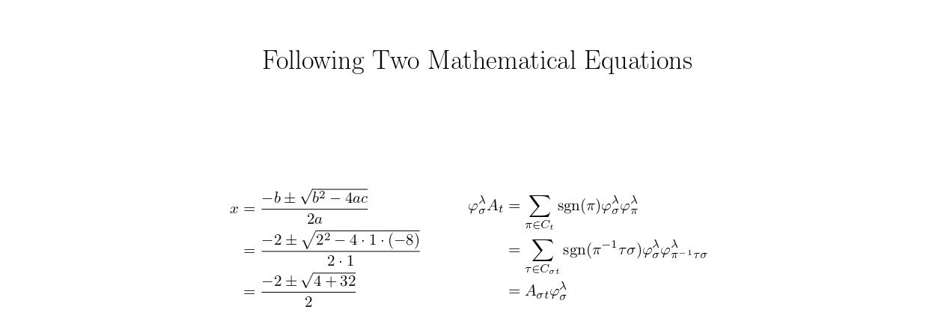

**8. Develop a LaTeX script to demonstrate the presentation of Numbered theorems, definitions, corollaries, and lemmas in the document .**

\documentclass{article}

\usepackage{amsthm}

% Define theorem-like environments

\newtheorem{theorem}{Theorem}

\newtheorem{definition}{Definition}

\newtheorem{corollary}{Corollary}

\newtheorem{lemma}{Lemma}

\begin{document}

\title{Numbered Theorems, Definitions, Corollaries, and Lemmas in the Document}

\date{}

\maketitle

\begin{theorem}

(Pythagorean Theorem) In a right-angled triangle, the square of the length of the hypotenuse

is equal to the sum of the squares of the lengths of the other two sides.

\begin{equation}

a^2 + b^2 = c^2

\end{equation}

\end{theorem}

% Presenting a definition with an example

\begin{definition}

(Prime Number) A prime number is a natural number greater than 1 that is not divisible by any number other than 1 and itself.

\begin{itemize}

\item Example: 2, 3, 5, and 7 are prime numbers.

\end{itemize}

\end{definition}

% Presenting a corollary with an example

\begin{corollary}

(Euclid's Corollary) There are infinitely many prime numbers.

\begin{itemize}

\item Proof: Assume there are finitely many primes. Let them be $p_1, p_2, \ldots, p_n$.Consider the number $N = p_1 \cdot p_2 \cdots p_n + 1$.This number is not divisible by any of the primes $p_1$ through $p_n$.Therefore, there must be a prime factor not in the list, contradicting the assumption that there are only finitely many primes.

\end{itemize}

\end{corollary}

% Presenting a lemma with an example

\begin{lemma}

(Basic Arithmetic Identity) For any real numbers $a$ and $b$, we have:

\begin{equation}

(a + b)^2 = a^2 + 2ab + b^2.

\end{equation}

\end{lemma}

\end{document}

**OUTPUT:-**

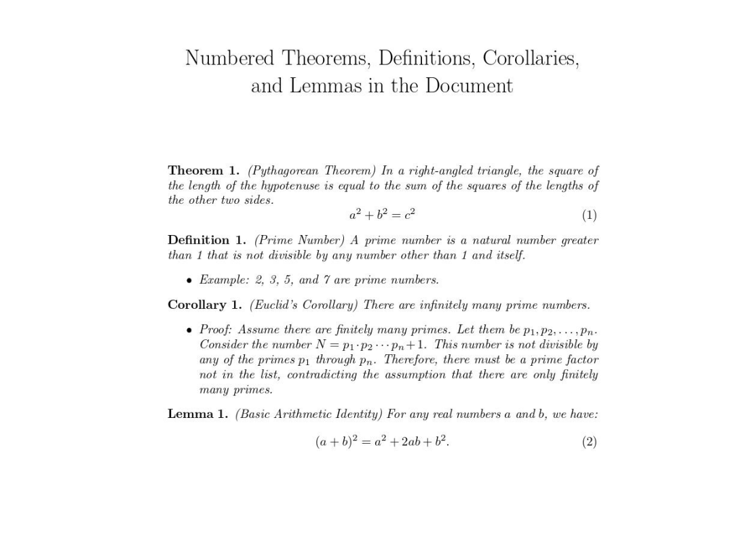

**9. Develop a LaTeX script to create a document that consists of two paragraphs with a minimum of 10 citations in it and display the reference in the section .**

\documentclass{article}

\usepackage[numbers]{natbib} % Use the 'natbib' package for citation management

\begin{document}

\title{Document that Consists of Two Paragraphs with a minimum of 10 Citations in it and Displaying the References in the Section}

\date{}

\maketitle

% Write two paragraphs with at least 10 citations

\paragraph{Paragraph 1}

The theory of relativity has been explored extensively in various scientific papers \citep{author1, author2, author3}. Einstein's contributions to physics are profound and have paved the way for many modern discoveries \citep{author4, author5}. Researchers continue to

investigate the complexities of spacetime and the universe \citep{author6, author7}. These advancements have led to new methods of measurement and analysis in cosmology \citep{author8}.

\paragraph{Paragraph 2}

Recent studies have focused on the impact of climate change on various ecosystems \citep{author9, author10}. Scientists are examining how rising temperatures and changing weather patterns affect biodiversity and human health \citep{author11, author12}. Furthermore, interdisciplinary research has brought about innovative solutions for sustainable development \citep{author13}. Collaboration among experts from different fields is essential to address the challenges of global warming \citep{author14}.

% Add a references section

\newpage % Optional: Start the references on a new page

\begin{thebibliography}{99}

\bibitem{author1} Author One. \textit{Title of Article One}. Journal Name, vol. 10, no. 1, pp. 1--10, 2022.

\bibitem{author2} Author Two. \textit{Title of Book Two}. Publisher Name, 2021.

\bibitem{author3} Author Three. \textit{Title of Conference Paper Three}. In: Proceedings of Conference, pp. 100--110, 2020.

\bibitem{author4} Author Four. \textit{Title of Article Four}. Journal Name, vol. 9, no. 2, pp. 15--25, 2019.

\bibitem{author5} Author Five. \textit{Title of Book Five}. Publisher Name, 2018.

\bibitem{author6} Author Six. \textit{Title of Conference Paper Six}. In: Proceedings of Conference, pp. 200--210, 2017.

\bibitem{author7} Author Seven. \textit{Title of Article Seven}. Journal Name, vol. 8, no. 3, pp. 30--40, 2016.

\bibitem{author8} Author Eight. \textit{Title of Book Eight}. Publisher Name, 2015.

\bibitem{author9} Author Nine. \textit{Title of Conference Paper Nine}. In: Proceedings of Conference, pp. 300--310, 2014.

\bibitem{author10} Author Ten. \textit{Title of Article Ten}. Journal Name, vol. 7, no. 4, pp. 50--60, 2013.

\bibitem{author11} Author Eleven. \textit{Title of Article Eleven}. Journal Name, vol. 6, no. 5, pp. 70--80, 2012.

\bibitem{author12} Author Twelve. \textit{Title of Article Twelve}. Journal Name, vol. 5, no. 6, pp. 90--100, 2011.

\bibitem{author13} Author Thirteen. \textit{Title of Book Thirteen}. Publisher Name, 2010.

\bibitem{author14} Author Fourteen. \textit{Title of Conference Paper Fourteen}. In: Proceedings of Conference, pp. 400--410, 2009.

\end{thebibliography}

\end{document}

**OUTPUT:-**



% Page 1

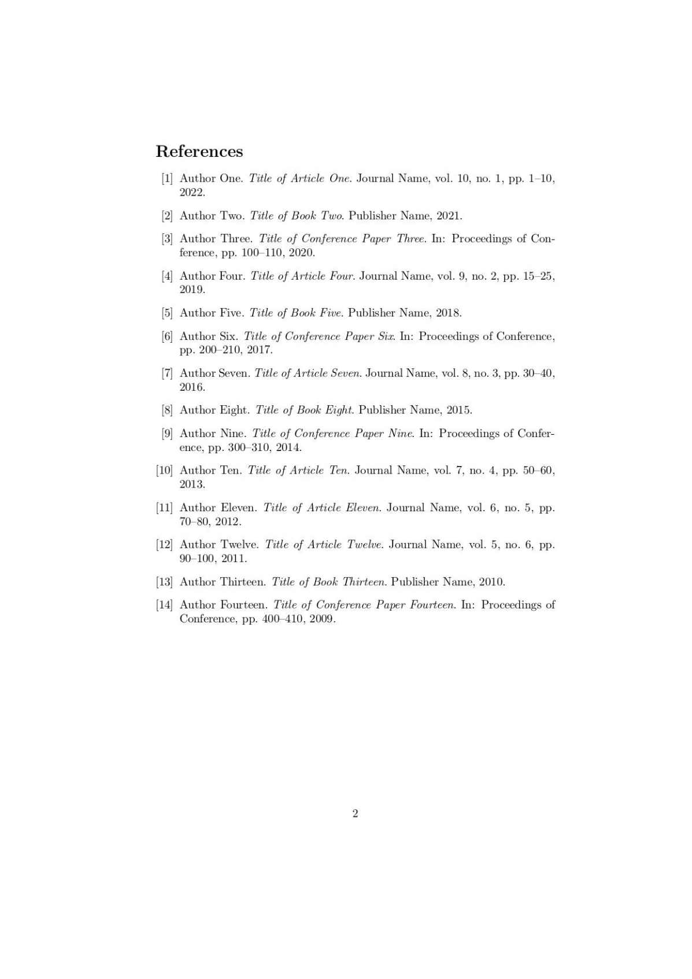

% Page 2

1. **Develop a LaTeX script to design a simple tree diagram or hierarchical structure in the document with appropriate labels using the Tikz library.**

\documentclass{article}

% Import the 'tikz' package for creating diagrams

\usepackage{tikz}

\usetikzlibrary{trees}

\begin{document}

\title{Simple Tree Diagram or Hierarchical Structure in the Document with appropriate

Labels using the Tikz Library}

\date{}

\maketitle

% Create a tree diagram

% Wrap the TikZ picture in a 'center' environment to center the diagram

\begin{center}

\begin{tikzpicture}[

level 1/.style={sibling distance=7cm},

level 2/.style={sibling distance=4cm},

level distance=2cm,

every node/.style={font=\large} % Increase font size here (e.g. \large, \Large)

]

% Root node

\node {Root}

% Level 1 nodes

child { node {Child 1}

% Level 2 nodes

child { node {Grandchild 1.1} }

child { node {Grandchild 1.2} }

}

child { node {Child 2}

% Level 2 nodes

child { node {Grandchild 2.1} }

child { node {Grandchild 2.2} }

};

\end{tikzpicture}

\end{center}

\end{document}

**OUTPUT:-**

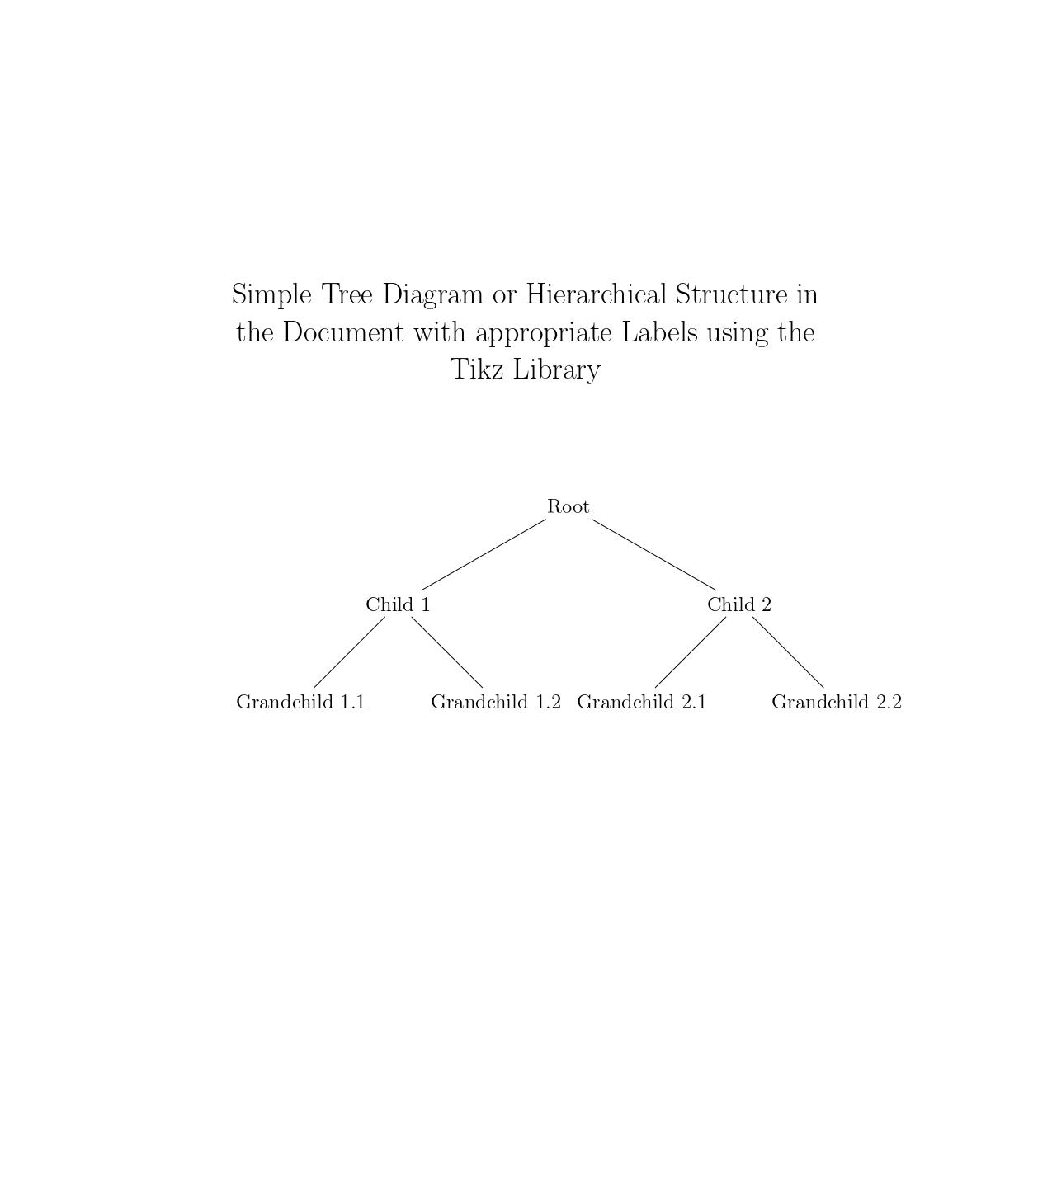

1. **Develop a LaTeX script to present an algorithm in the document using Algorithm/algorithmic/algorithm2e library.**

\documentclass{article}

\usepackage[ruled, linesnumbered]{algorithm2e}

\begin{document}

\begin{algorithm}[H]

\SetAlgoLined

\SetKwFunction{Dijkstra}{Dijkstra}

\SetKwProg{Fn}{Function}{:}{}

\Fn{\Dijkstra{$G, s$}}{

$d[s] \gets 0$\;

\ForEach{$v \in V$}{

$d[v] \gets \infty$\;

$prev[v] \gets$ undefined\;

}

$Q \gets V$\;

\While{$Q$ is not empty}{

$u \gets$ vertex in $Q$ with minimum $d[u]$\;

Remove $u$ from $Q$\;

\ForEach{$v \in$ neighbors of $u$}{

$alt \gets d[u] + \mathrm{weight}(u, v)$\;

\If{$alt < d[v]$}{

$d[v] \gets alt$\;

$prev[v] \gets u$\;

}

}

}

\KwRet{$d[], prev[]$}\;

}

\caption{Dijkstra's Algorithm}

\label{algo:dijkstra}

\end{algorithm}

\end{document}

**OUTPUT:-**

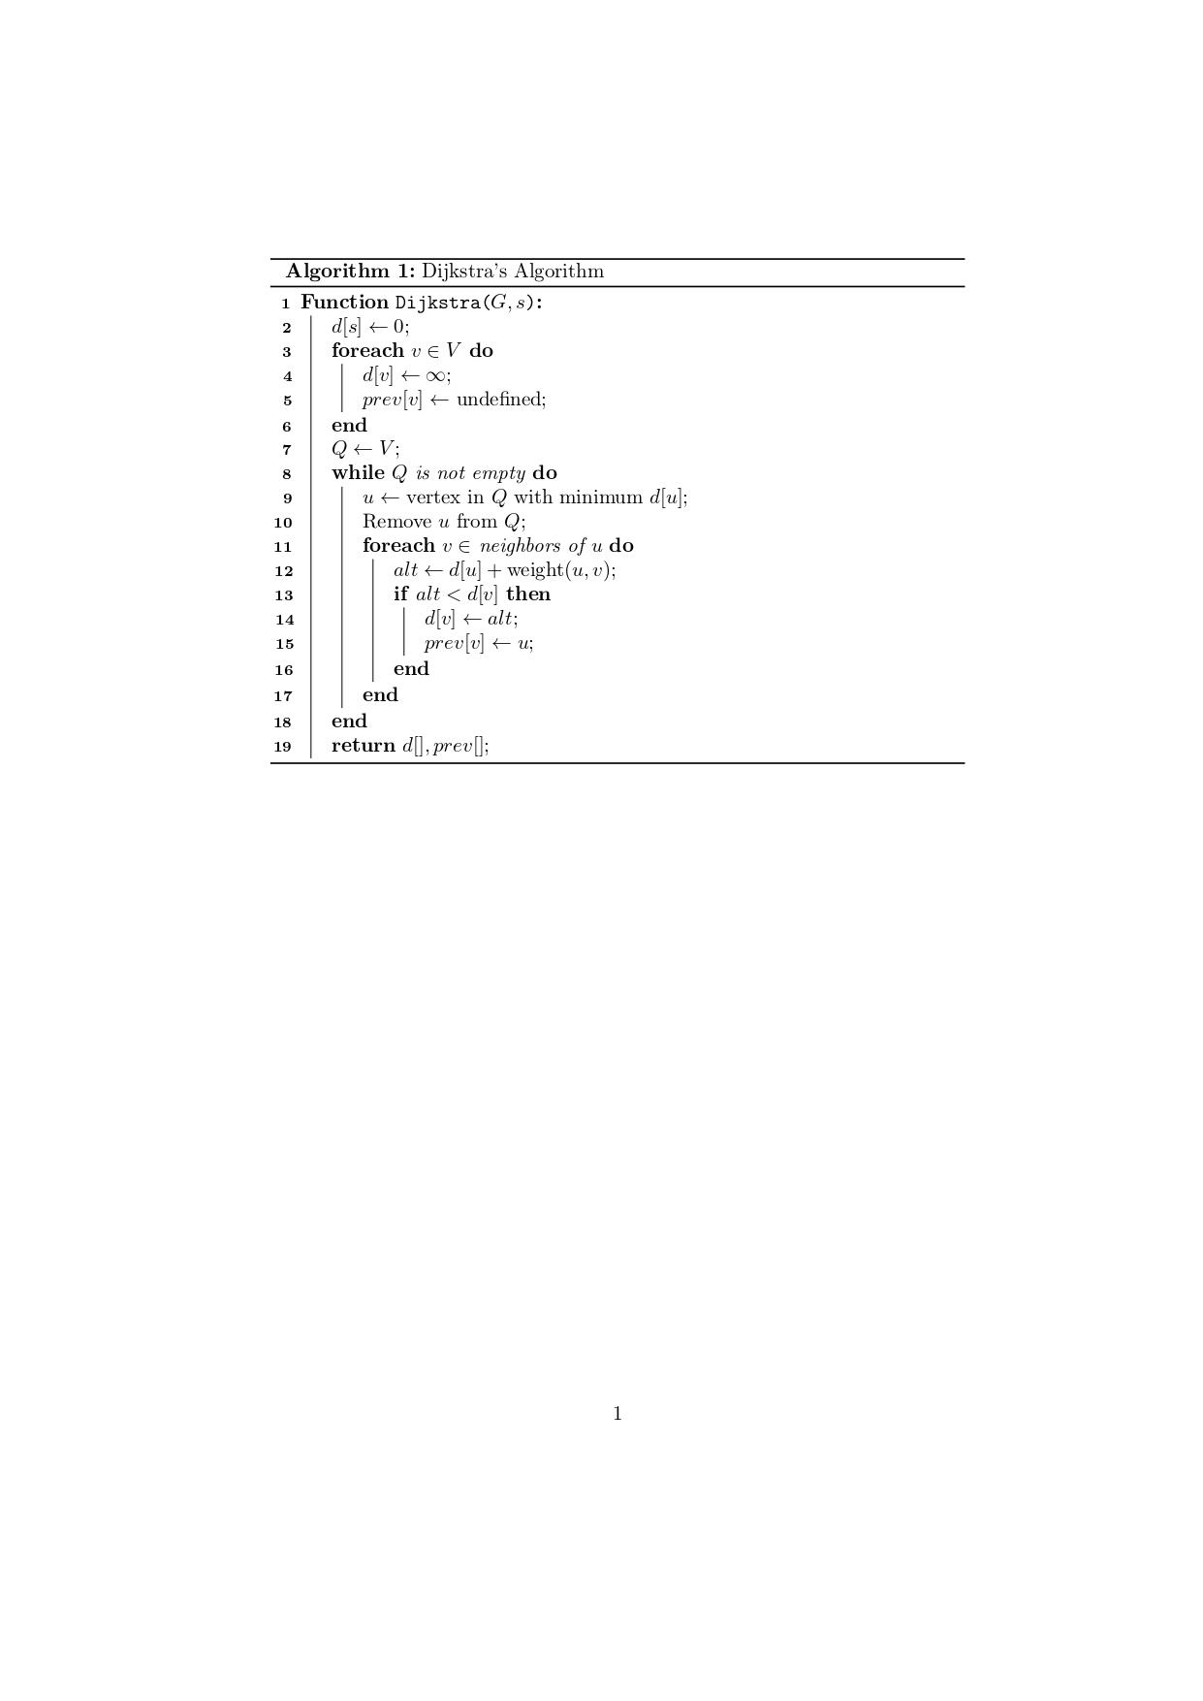

**12. Develop a LaTeX script to create a simple report and article by using suitable commands and formats of user choice.**

\documentclass[conference]{IEEEtran}

\IEEEoverridecommandlockouts

\usepackage{cite}

\usepackage{url}

\usepackage{amsmath,amssymb,amsfonts}

\usepackage{algorithmic}

\usepackage{graphicx}

\usepackage{textcomp}

\usepackage{xcolor}

\usepackage{stfloats}

\usepackage{multicol}

\def\BibTeX{{\rm B\kern-.05em{\sc i\kern-.025em b}\kern-.08em

T\kern-.1667em\lower.7ex\hbox{E}\kern-.125emX}}

\begin{document}

\title{COVID-19 and Comorbidities Pandemic Effects: A Review \\}

\author{\IEEEauthorblockN{Pavan.M,Sairam}

\IEEEauthorblockA{ Department of Computer Science and Eng(AI & ML), KVGCE, SULLIA}}

\maketitle

\begin{abstract}

%COVID-19 is a contagious disease caused by a virus,the Severe Acute Repository Syndrome coronavirus -2 (SARS-CoV-2). The first known case was identified in Wuhan, China, in December 2019.The co-existence of two or more illness or disorders in a single patient. This study received the Comorbidities and vulnerability among people pre and post COVID-19. An advanced database search is made related to modern technology towards COVID-19, In recent year, many health cares have increased and attracted attention, to make the issue serious by limited data healthy many techniques like Machine Learning and modern computational intelligence are applied to provide the disease.Many biomarkers are used to identify the condition of the patients. In this paper, COVID-19 was detected by different methods like Deep Learning Network Chest X-ray images and by applying a proposed weighted as arranging method which gives importance to different sensitivities of Deep Learning (DL) models on

different class types

A virus known as Severe Acute Repository Syndrome Coronavirus-2 (SARS-CoV-2) is the source of the infectious disease COVID-19. The first case of COVID – 19 is recorded in Wuhan, China, in December 2019. If a person had COVID-19 and another disease or condition, then COVID-19 and other diseases would be considered comorbidities. Researchers began studying the link between people with certain comorbidities and the COVID-19 disease after the start of the pandemic. This paper gives reviews on the effects of COVID-19 and its

comorbidities. Machine learning and Deep learning techniques are used to detect the severity of COVID-19 and the comorbidities from the existing literature work.

\end{abstract}

\begin{IEEEkeywords}

COVID-19, Comorbidity, Deep Learning,Machine Learning, SARS-CoV-2.

\end{IEEEkeywords}

\section{Introduction}

\IEEEPARstart{T}he disease known as COVID-19 is mostly caused by the SARS-CoV-2 virus, which was discovered in China in December 2019. As a result, it spread fast around the world.COVID-19 spreads through air-borne patients containing the virus or the droplets. The

Transmission can occur through the contaminated fluids in the eyes, nose or mouth, and, rarely, via contaminated surfaces. COVID-19 affects different people in different ways. Most infected people will develop mild

to moderate illness and recover without hospitalization. The symptoms of this disease can be categorized into three types such as most common, less common, and serious problems. The most common symptoms of the COVID -19 are fever, cough, tiredness, and loss of taste or smell. The less common symptoms are sore throat, headache, aches, and pains, diarrhoea, a rash on the skin, or discoloration of fingers or toes, and red or irritated eyes. The Serious symptoms are difficulty in breathing or shortness of breath, loss of speech or mobility, or confusion and chest pain. Fig. 1 shows the three categories of symptoms of COVID-19 disease. The Covid-19 patient seeks immediate medical attention if he has serious symptoms. People with mild symptoms who are otherwise healthy should manage their symptoms at home. On average, it takes 5–6 days from when someone is infected with the virus for symptoms to show,

however it can take up to 14 days.

This disease weakens the body's functions, making it more challenging for the body to fight off invaders like viruses and bacteria and to get rid of the disease's main cause. It may be

extremely stressful on the body to have two or more diseases present at once, and the affected individual may take longer to recover than someone without comorbidity.

COVID-19 spreads through, air-borne patients containing the virus or the droplets. Transmission can occur through the contaminated surface.

The Transmission can occur through the contaminated fluids in the eyes, nose or mouth, and, rarely, via contaminated surfaces. COVID-19 testing through swab as well as rRT-PCR and CT scan methods.

The Table 1 is the COVID cases (43452164)and Death cases (525116) in India (March 2020 to October 2022).

\begin{table*}

\caption{COVID cases in States / Union Territories}

\label{tab:t1}

\centering

\begin{tabular}

{p{0.10\linewidth}

p{0.10\linewidth}p{0.10\linewidth}p{0.10\linewidth}p{0.10\linewidth}p{0.10\linewidth}

p{0.10\linewidth}p{0.10\linewidth}p{0.10\linewidth}p{0.10\linewidth}p{0.10\linewidth}

p{0.10\linewidth}

\hline

\textbf{Sl.No.} & \textbf{COVID Cases} & \textbf{Death Cases} & \textbf{Result}\\

\hline

Yamaç \emph{et al.} \cite{yamac2021convolutional} 2021 &

SVM, KNN, and CRC & X-ray images of QaTa-Cov19 & Sensitivity: 98\%

\newline

Specificity:95\%

\end{tabular}

\end{table*}

\begin{figure}[htp]

\centering

\includegraphics[width=8cm,height=9

cm]{Sym.JPG} \caption{Symptoms of COVID-19 Effects}

\label{fig:f1}

\end{figure}

26

\subsection*{A. COMORBIDITIES}

Comorbidities are the presence of two or more diseases in the same person. In the case of COVID-19, if a person had COVID-19 and another disease, then COVID-19 and the other condition would be comorbidities. So, for example, if a person had diabetes and then developed COVID-19, they would have two diseases—or comorbidities.

\newline

Table 2 is existing diagnosis algorithm for comorbidities are incorporated.

\begin{figure*}[htp]

\centering

\includegraphics[width=14cm,height=8cm]{Suresh_2.png}

\caption{Death Rate by Comorbidities diseases}

\label{fig:f2}

\end{figure*}

\subsection*{B. DIAGNOSIS ALGORITHMS}

Table 3 is existing diagnosis algorithm for diseases are incorporated.

\begin{table*}

\caption{Existing diagnosis algorithm for comorbidities}

\label{tab:t1}

\centering

\begin{tabular}

{p{0.20\linewidth} p{0.15\linewidth}p{0.20\linewidth}p{0.20\linewidth}p{0.20\linewidth}}

\hline

\textbf{Author [Reference] Year} & \textbf{Model / Classifier} & \textbf{Dataset} &

\textbf{Result}\\ %\textbf{Age in Years} &

\hline

Yamaç \emph{et al.} \cite{yamac2021convolutional} 2021 &

SVM, KNN, and CRC & X-ray images of QaTa-Cov19 & Sensitivity: 98\%

\newline

Specificity:95\%

\\\\

Wanyan \emph{et al.} \cite {wanyan2020relational} 2021 & DL/ML - Heterogeneous Graph

model and LSTM & Electronic Health Records & Training set Accuracy:0.935

\newline

Test set Accuracy:0.847

\\\\

Liu \emph{et al.} \cite {liu2020risk} 2020 & Risk factors of infection in COVID-19: RT-PCR

& 11580 of persons & RR: 5.29, 95\%CI: 3.76-7.46

\\\\

Gammulle \emph{et al.} \cite {gammulle2021multi} 2021 &

DL-SE-ResNet-50 & 307 patients of radiomics & Accuracy:86.63\%

\\\\

Pathak \emph{et al.} \cite {pathak2020deep} 2020 & AI- CNN, ANN & 2842 CT Scan images

& Accuracy:1.79, AUC:1.53

\newline f-measure:1.84, Sensitivity:1.93

\newline

Specificity:0.44, recall:1.64

\newline

Precision:1.53

\\\\

Han \emph{et al.} \cite {han2020accurate} 2020 &

27

DL/ML - CatBoost / SVM / NB / LR & EMRs: Test 1 (753)

Test 2(2123)

& Accuracy:97.6, AUC:99

\newline f1 score:97.9,Precision:97.9

\newline

Cohen Kappa:95.7, recall:97.9

\\\\

\hline

\end{tabular}

\end{table*}

\begin{table*}

\caption{Existing diagnosis algorithm for Diseases}

\label{tab:t2}

\centering

\begin{tabular}

{p{0.20\linewidth} p{0.15\linewidth}p{0.20\linewidth}p{0.20\linewidth}p{0.20\linewidth}}

\hline

\textbf{Author [Reference] Year} & \textbf{Model / Classifier} & \textbf{Dataset} &

\textbf{Result}\\ %\textbf{Age in Years} &

\hline

Mehrabadi \emph{et al.} \cite{mehrabadi2021detection} 2021&

DL – CNN / LSTM & 77972 samples of Age & ACU: 0.81

\\\\

Singh \emph{et al.} \cite {singh2021ediapredict} 2021 & ML - XGBoost, Decision Tree,

Random Forest, NN & PIMA Indian Diabetes Data 9 attributes & Accuracy:92.21\%

\\\\

Karboub \emph{et al.} \cite {karboub2020automated} 2022 & AI-CNN, SVM, KNN, NB &

72000 ECG Beats & Accuracy:99.2\%

\\\\

Handy \emph{et al.} \cite {Handy923} 2022 &

logistic and Cox Regreession & 972971 Female and CHA samples & Odds Ratio:95\%

\\\\

Aburuz \emph{et al.} \cite {aburuz2022clinical} 2022 & logistic Regression Analysis & 3296

patients Age & Odds Ratio:2.87

\\\\

Yu \emph{et al.} \cite {yu2020role} 2021 &

AI - CatBoost / SVM / NB / LR & EMRs: Test 1 (753)

\newline

Test 2(2123)

& T1-Accuracy: 84.7\%

\newline

T2-Accuracy:96.7\%

\\\\

\hline

\end{tabular}

\end{table*}

\section{ Literature Review }

In literature reviews severity of COVID-19 and comorbid effects and diagnosis algorithms are reviewed and explained.

\newline

Devarajan \emph{et al.} \cite {devarajan2021healthcare} investigated on the effect of the COVID-19 flare-up on medical services tasks and creates AI based anticipating models utilizing time series information to predict the movement of COVID-19 and further utilizing prescient examination to all the more likely oversee medical care activities.

Gu \emph{et al.} \cite {gu2021epidemic} proposed novel plague risk evaluation technique in light of the granular information gathered by correspondence stations. The calculation scourge hazard of the correspondence stations in various stretches by consolidating the quantity of tainted people and the manner in which they go through the stations has been examined.

Li \emph{et al.} \cite {li2021rapid} the component determination strategy in view of stepwise relapse is utilized to handle the COVID-19 pandemic informational index from January 13,2020 to January 16, 2021 in the United States. After measurable testing, the Auto Regressive Integrated Moving Average (ARIMA) model and the better ARIMAX model in the view of element determination rapidly settles the improvement pattern of the COVID-19 pestilence in the US.

Elahraf \emph{et al.} \cite {elahraf2021service} proposed a help situated structure that permits dynamic piece and the executives of such quiet consideration plans expecting a fitting Information base and accessibility of web administrations points of interaction of the fundamental frameworks of guardians and specialist organizations.

Feil-Seifer \emph{et al.} \cite {feil2020next} propose Human-Robot Interaction Research (HRI) research acted before long will be changed in essentially various ways; the powerlessness to perform or expect the future presentation of in-person human subjects research, particularly research including material or multiparty cooperation, will change both

the prevailing systemic methods utilized by HRI specialists and the very research questions that the field decides to and can address.

Khan \emph{et al.} \cite {khan2020prediction} foresee whether the cesarean segment is important with the assistance of information mining and subsequently, expanding the security of the mother and infant during and after labor by keeping away from superfluous cesarean area has been tended to. To accomplish the goal, three unique gathering forecast models in view of XGBoost, AdaBoost and Catboost have been created.

Jokinen \emph{et al.} \cite {jokinen2021detection} utilized atomic elements reproductions in combined solvents as one with virtual screening to distinguish little particles that could be possible inhibitors of S protein in turn ACE2 collaboration. Likewise, an original conformity of the S protein was found that could be balanced out by little particles to restrain connection to ACE2.

Kyono \emph{et al.} \cite {kyono2021exploiting} propose a model determination strategy for utilizing model expectations on an objective space without names by taking advantage of the area invariance of causal design. We expect or gain a causal chart from the source space and select models that produce anticipated disseminations in the objective space that have the most elevated probability of accommodating our causal diagram.

\section{Conclusions}

Our meta- analysis showed that diabetes increases the mortality of patients with COVID-19. Even since COVIS-19 had occur in environment may her infected by SAR-COV-2. The rate of infection is detected by virus health data and cough detectors and even by long health detectors. The heart disease caused due to cardiovascular infection affects many severe maybe causing pandemic and cardiovascular compliance and leading death computer addiction and human robot interaction have experienced the detection of disease, to main the issue serious by limited

data health many techniques like, ML modern continuous intelligence are applied to predict the diseases. Many biomarkers are used to identify the condition of the patients. In this paper, COVID-19 was detected by different methods like Deep Learning Network Chest X-ray images and by applying a proposed weighted as arranging method which gives importance to different sensitivities of DL models on different class types.

\bibliographystyle{ieeetr}

\bibliography{reference}

\end{document}

**OUTPUT:-**

